Keshav Memorial Institute of Commerce and Sciences
(Affiliated to Osmania University) Narayanaguda, Hyderabad, Telangana.

Department of English Activities
(2018-19)
Date:1/7/2019
Report on Orientation Program for Competitive Exams Aspirants
“QUANTITATIVE APTITUDE, LOGICAL REASONING AND COMPETITIVE ENGLISH”
Organized by the Department of English, Mathematics and Computer Science
Venue: S.V.Hall KMICS
Timings: 2pm TO 3pm
No of participants attended the program: 102
Note: interested participants from BCOM and BSC first and second year students can register in the course.
Resource persons of the program: Dr. Nageshwar Rao (the principal of kmics), Mrs.P.Madhuri Thaide (dept of English), Mrs. A.Venuka (dept of mathematics) and Mrs.Bhargavi (dept of computer science)
In this competitive world, success in every competitive examination like MBA, CAT, MAT, Bank PO’s, S.I,SSC, Railways or even campus interviews depends much on the candidates performance in quantitative aptitude , logical reasoning and his understanding of English grammar and vocabulary.
The aptitude test is used as a measure of the abilities of a person. These tests give the complete picture of a person’s mind. In most of the exams, aptitude test is conducted as a part of the written exam which is usually the very first round of selection procedure. This tests your mental alertness. A suitable candidate needs to be mentally alert to the changes happening around him/her. Aptitude test basically involves mathematical questions where speed of candidate matters more than his/her knowledge and this needs aptitude tricks.
Logical reasoning is a result of a person’s critical thinking and wisdom. It is how a person applies a rational to number of practices and phenomena in every day experience. The various mind games like Rubik cubes, Sudoku and puzzles are all solved through logical reasoning and critical thinking. It has been a most widely used tool in lot of competitive exams. Logical reasoning tests are a form of psychometric testing and are also widely used by corporate employers to help access candidates during their recruitment process.
Every competitive exam is conducted in English language. English is preferred in competitive exams because it judges the candidates vocabulary knowledge. This is an important factor where the examiners judge your possible ways to stand out from the crowd. English is accepted as an international language. Lack of English language will not help in communicating ideas clearly. English is recognized as a major aspect in almost all competitive exams of today’s world.
To master all these, training is a must…!
So the management has decided to start a certificate course on “Quantitative Aptitude, logical Reasoning and Competitive English” for the students of KMICS.

The principal motivated the students to get benefited from this orientation program. He mentioned that there is the need for conducting this program to help students to gain the knowledge about the competitive exams and motivate them to have confidence to achieve success in their chosen field. This coaching class will help all the students especially those who have financial problems to receive coaching outside the college. He said that this college is always willing to help the students and community.
The resource persons of the program motivated them to prepare well for competitive exams, discussed with them the marks for each section of the common paper and the syllabus. Each resource person guided the student to know how important to excel in competitive exams. What is required to prepare for the various jobs in government sectors and private sectors? Like Jobs in banks, railways, IT companies defense, police and army etc.
The fees for the course is 500 rupees per student
Duration of the course 90 hours course
Timings; 2pm to 4pm

The Syllabus of the course
General English syllabus
Parts of speech
Sentences
Kinds of sentences
Tag questions
Tenses
Verb forms
kinds of verbs
Voice
Degrees of comparison
Word Analogy
Simple complex and compound sentences
Concord
Articles
Phonetics
Reported speech
Common Errors
Sentence Improvements
Vocabulary
Synonyms/ Antonyms
One Word Substitution
Idioms –Phrases
Reading comprehension

Logical Reasoning
- Series Completion
- Analogy
- Classification
- Coding and decoding
- Blood relations
- Puzzle Test
- Sequential Output Tracing
- Directions
- Arithmetical Reasoning
- Inserting the missing character
- Data sufficiency
- Eligibility test
- Assertion and Reason
- Situation Reaction Test
- Verification of Truth of the statement
- Statement-Arguments
- Statement-Assumptions
- Statement-Course of Action
- Statement-Conclusions
- Deriving Conclusions from passages
- Theme Detection
- Cause and Effect
- Logical Venn Diagrams
- Alphabet Test
- Alphanumeric Sequence Puzzle
- Number Ranking and Time Sequence Test
- Mathematical Operations
- Logical Sequence of Words
Quantitative Aptitude
1. Introduction to Number System
2. H.C.F &amp; L.C.M
3. Decimal Fractions
4. Simplification
5. Square roots and cube roots
6. Average
7. Problems on numbers
8. Problems on ages
9. Surds and indices
10. Percentages

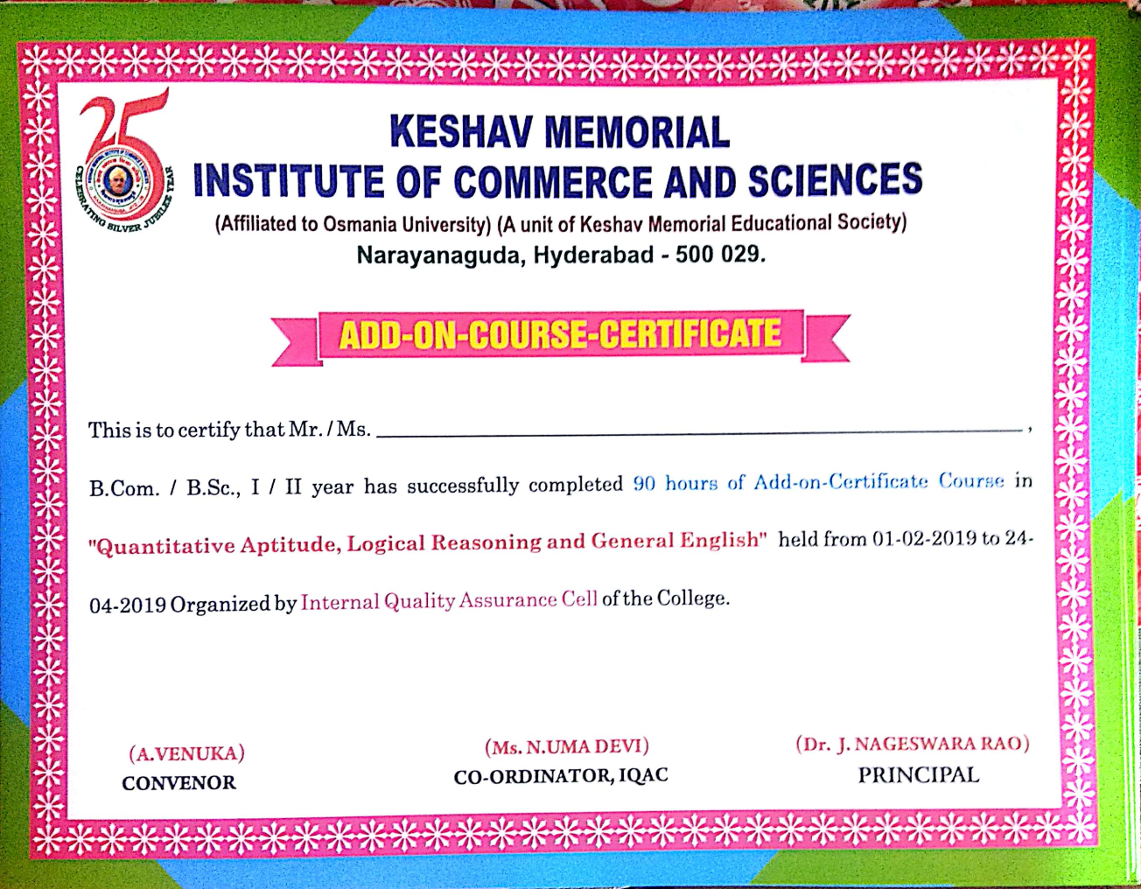
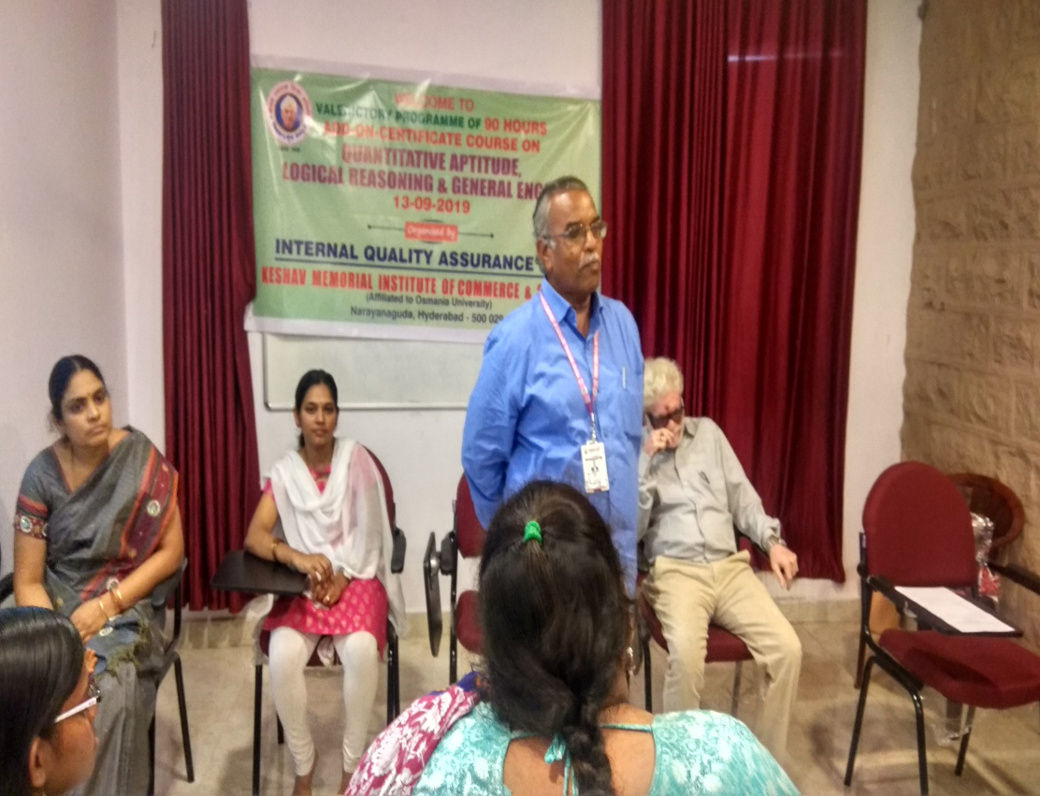

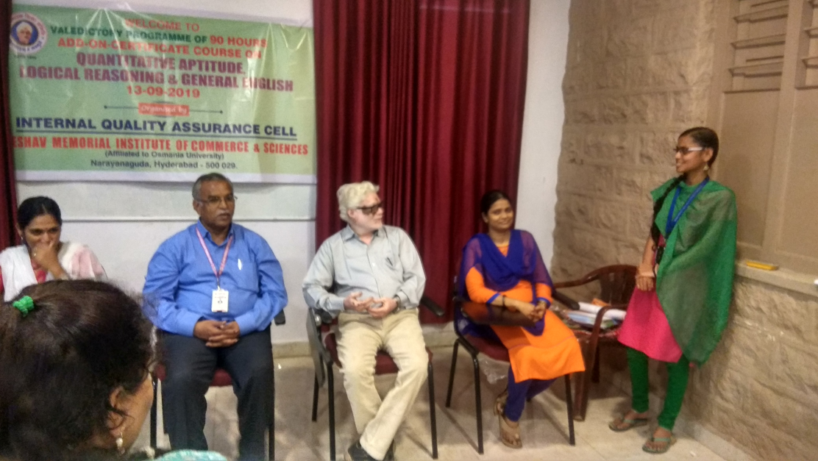

Keshav Memorial Institute of Commerce and Sciences
Student Feed Back Form
2018-2019
Name of the course: Logical Reasoning Quantitative Aptitude and General English
Name of the Resource Persons: Mrs.A.venuka, Mrs.P.Madhuri Thaide, Mrs. Bhargavi
Name of the student:
Class:
Roll No:
Email Id:
Mobile No:
Address:
Would you require coaching classes for competitive exams in future? Yes\No
Feedback\Suggestion:
____________________________________________________________________________________________________________________________________________________________________________________________________________________________________________________________________________

